**CST-361 Design Patterns in Java**

**Student** **Name**: Michael Weaver

**Project** **Title**: REST API

**Date**: 01/20/2019

**GitHub URL**: <https://github.com/battousairurik/CST361_Design_Patterns_In_Java>

REST API FLOW

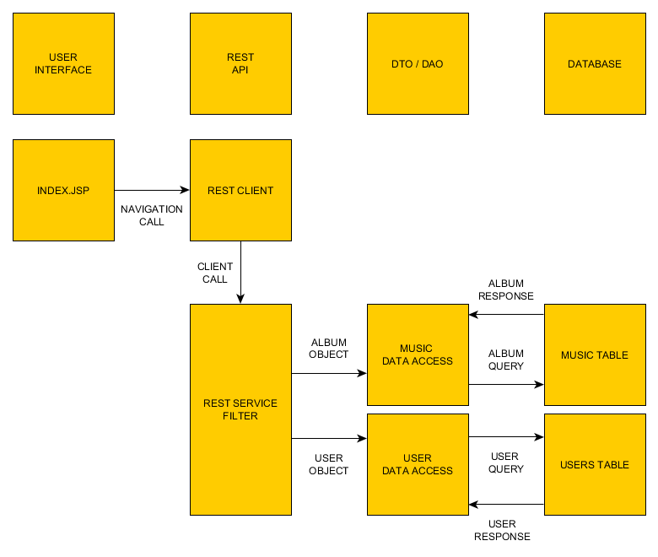

ALBUMS VIEW

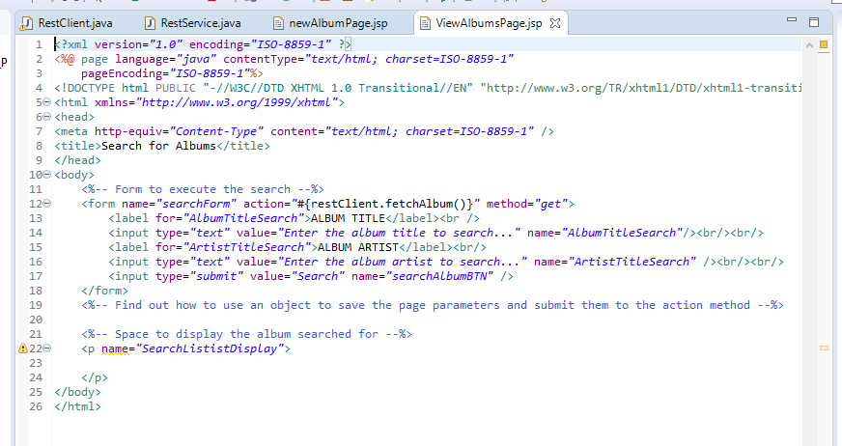

NEW ALBUM PAGE

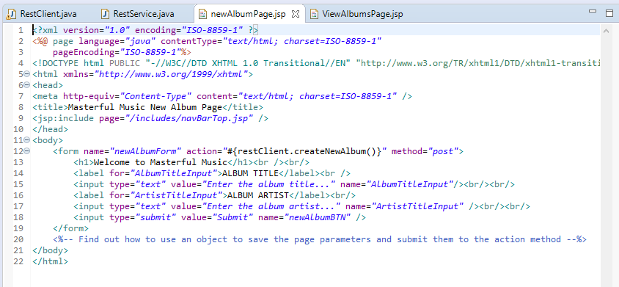

REST CLIENT

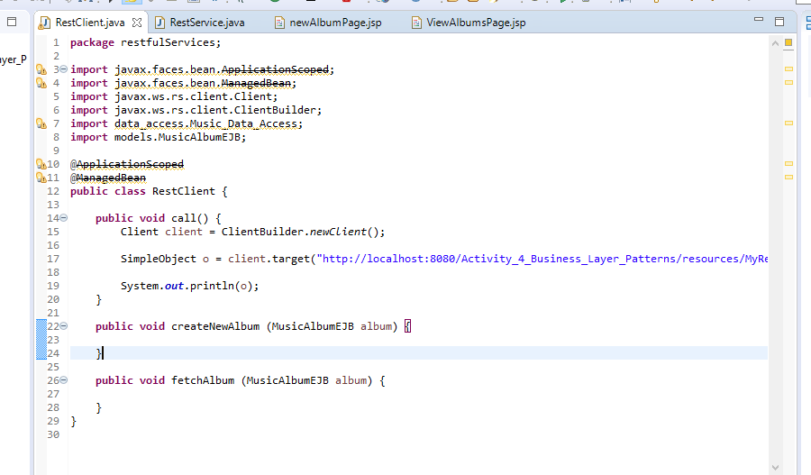

REST SERVICE

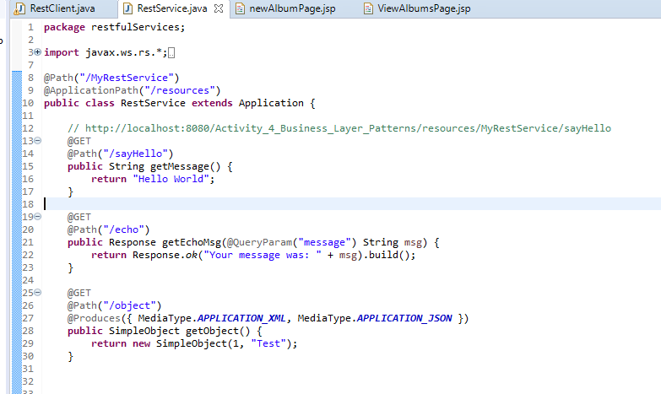

Approach

Even without full implementation of the Restful service, I can see how it ties in with the DAO pattern. By utilizing REST calls, the web service can be directed to the correct location to handle a particular call. A REST service tagged with GET and a path /albumList can contain a method to pass information to a data access object, which then retrieved the data from the database, passes it back to the RESTful client, which then handles the rest of the retrieval information. The same goes for one marked POST, where the inputted data is saved to the database via passed objects and the DAO pattern.

Notes / Thoughts / Issues